Town of Richmond
News from Town Hall
March 23, 2018

Recycling/Trash

Recycling for Monday, March 26th will be paper.
9Please place your trash and recyclables in a location that is easily accessible for the hauler to collect. Also, please have your trash and recycling out by 7:00 AM to ensure that it is collected. If, for some reason it is not collected, the hauler encourages you to contact them directly at 442-8390 rather than calling Town Hall.

In addition, please be aware that the trucks used by the hauler are dual functioning trucks in that trash and recyclables are collected together but placed in separate compartments within the truck.

MASSBAR ASSOCIATION OFFERING FREE LEGAL ADVICE: On Thursday, April 12th the MassBar Association is offering free legal advice through their “Dial-A-Lawyer” program. From 4:00 – 7:00 PM that day ONLY you can dial (413) 782-1659 to be put in touch with a lawyer who can answer your questions.

The Board of Health’s newly adopted Smoke-Free Regulations will go into effect on April 1, 2018: This new regulation bans smoking in town parks, town buildings, town-owned vehicles, in cemeteries, and at the town beach. Violations range from a warning to $300 per day/offense. The full-version of the new regulation can be found on the Town’s website at www.richmondma.org.

The Town Caucus will be held on Monday March 26th at 7:00 pm at the Richmond Town Hall. Town election nomination papers must have the signatures of 25 registered voters and be submitted to the Town Clerk at least 10 days prior to the caucus date. The Caucus Chair will also accept additional nominations from the floor. For questions, contact the Town Clerk at: clerk@richmondma.org.

The Tennessee Gas Pipeline Company will begin excavating portions of its pipeline near Sleepy Hollow Road and Steven’s Glen Road in the coming weeks for routine maintenance within its existing right-of-way. The work is expected to occur between April 2, 2018 and June 15, 2018. Abutters can expect to receive a written notification by mail. For questions related to this work, please contact the Gas Company directly. The 24-hour toll free number is 1-800-781-4152

Important Registry of Motor Vehicles information:
- There will be no motor vehicle inspections in Massachusetts on March 23, 24, or 25.
- The Registry of Motor Vehicles is transitioning to a new technology which will mean that RMV service centers will be closed on March 23 and AAA locations will be unable to offer RMV services on March 23 and 24.
- RMV online services will be unavailable as of 7 p.m., Thursday March 22 and until 8 a.m., Monday, March 26.

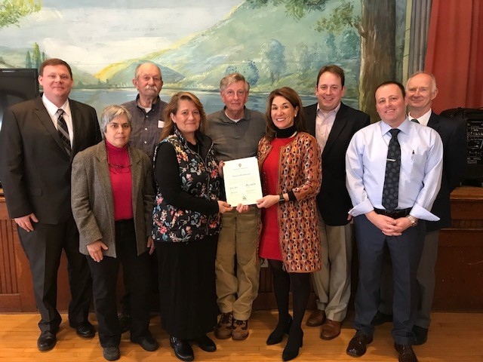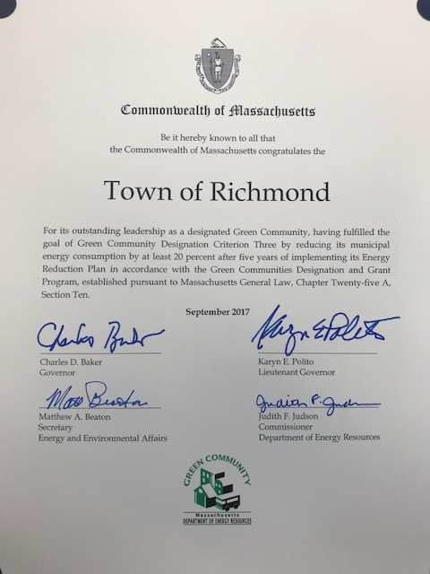
Thank you to Lt. Governor Polito, Green Communities Director Nick Connors, and Jim Barry, our DOER Regional Coordinator, for visiting Richmond and presenting us with a certificate for reaching our goal of reducing energy consumption by at least 20 percent. Congrats to our staff for making this possible!

Alternate Electrical Inspector Needed. A part-time/as-needed Inspector position is available for an electrician holding a valid Massachusetts license. For more information, please contact our Town Administrator at 698-3882 or townadmin@richmondma.org.

Volunteer Opportunities: The Town is still in need of a Field Driver and additional volunteers to assist in the occasional round-up of livestock when a local farmer is in need. If you or someone you know is interested in being on a call-list to serve when the need arises, please contact our Town Administrator at 698-3882, or townadmin@richmondma.org

The Town is also in need of a representative interested in local transportation: This position would require attendance at quarterly meetings to represent the town’s interests and would work closely with the Berkshire Regional Planning Commission. If you or someone you know is interested in serving in this capacity, please contact our Town Administrator at 698-3882, or townadmin@richmondma.org

THE RICHMOND FREE PUBLIC LIBRARY: As part of our Library Strategic Planning, we are creating an assessment of Richmond patrons (and non-users) needs and wants for the library. With this information, as well as visioning from our Strategic Planning Committee, we will be creating goals and objectives for the library’s future. In an effort to receive feedback from the greater Richmond community, we have created an online Library User Survey: https://www.surveymonkey.com/r/GYQRKXP

Application forms for the various Richmond scholarships are available at the post office, library, Town Hall and Bartlett’s Orchards, as well as at high school guidance offices. One application covers eight scholarships: The Anita Chapman, Joyce Spence, William and Hazel Dickson, Sarah MacDonald, Mildred Wheeler, Volunteer Fire Department/Malnati Family, George Kingsley, and Harold Kingsley.

Applicants must be year-round residents of Richmond and may be graduating seniors or college students. Applications should be sent to Patricia Malnati, State Road, by May 1.

PLEASE NOTE THis DATE HAS BEEN CHANGED: The Richmond Free Public Library Hosts a St. Patrick’s Day Celtic Chocolate Program – A FUN, EDUCATIONAL AND TASTY EVENT: Saturday, March 24th, 2018 at 11:00 AM. Program covers the history of chocolate and the Irish pioneers who helped along the way. The history of Celtic foods, lore, Irish poetry and samplings of Dublin tea, Irish bread, Blarney cheese and Celtic art chocolates. Program ends with a sing-a-long. (Made possible by a grant from the Richmond Cultural Council.)

From the Town Clerk: clerk@richmondma.org
Census and dog license renewals have been mailed out. Please return your census as soon as possible, whether or not any changes need to be made.

Also, dog licenses need to be renewed by April 1st to avoid a $5.00 late fee.

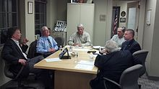
MEETINGS/OFFICE HOURS AT TOWN HALL

Tuesday, March 27th – Board of Assessors Hours - 9:00 AM – 12:00 Noon

Tuesday, March 27th – Municipal Building Cte. Meeting – 5:30-7:00 PM

Wednesday, March 28th – Board of Health Agents Hours – 9:00 – 1:00 PM

Wednesday, March 28th – Building & Zoning Hours – 9:30 – 11:00 AM

Wednesday, March 28th – Board of Assessors Hours – 1:00 – 4:00 PM

Wednesday, March 28th – Board of Selectmen Meeting – 6:00 PM

Thursday, March 29th – Tax Bill Mailing Committee Working Session – 8:30 AM – 1:30 PM

Budget Advisory Committee – FY’19

Wednesday, April 4th – School Budget (second meeting) – 6:00 PM

Wednesday, April 11th – Final Hearing and Vote on FY’19 Budget – 6:00 PM

Other Dates of Importance:

Wednesday, April 25th – Board of Selectmen to Sign Final Annual Town Meeting Warrant

Tuesday, May 8th – Last Day to Post Annual Town Meeting Warrant

Wednesday, May 16th – Annual Town Meeting at School – 7:30 PM

Saturday, May 19th – Town Elections – 11:00 AM – 7:00 PM at Town Hall

The Community Health Association:


Weekly Blood Pressure Clinics

The Community Health Association offers Blood Pressure Screenings every Thursday from 9:00 – 10:00 AM at the Congregational Church. No appointment needed. For more information contact Emilie Jarrett, RN: 413-232-0122 or via email at Emilie@charws.com.


Council on Aging News

COA Director

PLEASE NOTE - NEW OFFICE HOURS:
Monday – 10:00 AM – 3:30 PM
Tuesday - 10:00 AM - 3:30 PM
Wednesday – 10:00 AM – 3:30 PM
Thursday - 10:00 AM – 3:30 PM. She can be reached at 698-3656 or at COA@richmondma.org.

WINTER WEATHER PREPAREDNESS:

Emily Jarrett, RN of the Community Health Association, has provided me with an excellent one-page checklist to prepare for a possible winter storm. Following the instructions in the checklist will go a long way to assuring your safety and comfort in the event there is a major storm this winter.

Call me at 413-698-3656 or email me at coa@richmondma.org to request a free copy of the checklist.


COUNCIL ON AGING TRANSPORTATION SERVICE

The Council on Aging has increased the suggested cost per ride for its van service and clarified the extent of the area our vans will cover. Ride fees are, as always, suggested:

Any town in Berkshire County
Suggested Fee Per Ride: $5.00

Rides Outside of Berkshire County:
Northampton – Cooley Dickenson Hospital or the Veteran’s Hospital
Suggested Fee Per Ride: $10:00
West Springfield – Specialist Office
Suggested Fee Per Ride: $10:00
Springfield – Baystate Medical Center
Suggested Fee Per Ride: $15:00
Albany – Albany Medical Center
Suggested Fee Per Ride: $10:00

The Council on Aging is not able to provide rides to and from destinations outside of the acceptable distances listed above. Our drivers are volunteers, not paid for their time, it would, therefore, be unacceptable to ask them to devote an entire day to a ride taking 2-1/2 or more hours each way.

For transportation outside of our acceptable area, it is suggested that private arrangements be made with friends and family. Alternatively, you can contact the ambulance companies and arrange transportation with them – very often the cost of such rides is covered by medical insurance.

ONGOING CLASSES: 

Exercise Classes with Christine Faber:
Mon.—3:30 PM @ Richmond Cong. Church—Yoga
Wed.—3:30 PM @ School—Tai Chi
Thurs.—11:15 AM @ Town Hall— Osteo Exercise
Fri.—3:30 PM @ Town Hall—Line Dance
Want to join? Sign up with Christine at 413-243-2497 or rfaber9@msn.com

Meals on Wheels

The Elder Services of Berkshire County "Meals on Wheels" menu for February
is available on line at www.esbci.org/mow/current.pdf and on the COA bulletin board at Town Hall.

Need Food and/or Fuel Assistance?

You may be eligible for financial assistance from your friends and neighbors right here in town. Contact the Berkshire Community Action Council (BCAC) at 413-445-4503 or visit their website at https://bcacinc.org/. All correspondence is strictly confidential.

New Federal Fuel Assistance Income Limits for Fiscal Year 2017:
Household Size Gross Annual Income
1 $34,001.
2 $44.463.
3 $54,925.
4 $65,387.
5 $75,849.
6 $86,311.
7 $88.272.

Please Note: Persons in Richmond eligible for emergency fuel assistance are also eligible for food assistance through the South Congregational Church Food Pantry located at the rear of the building at 110 South Street in Pittsfield.

Pantry hours are: Wednesdays and Thursdays from 7:30 – 11:00 AM and Wednesday evenings from 5:30 – 6:00 PM.


Richmond Consolidated School

Follow this link to read about some exciting changes for Richmond Consolidated School
http://www.berkshireeagle.com/stories/richmond-consolidated-sees-big-changes-with-improved-arts-tech-and-foreign-languages,498807

School Newsletter

If you are interested in receiving the school’s weekly newsletter and other updates please contact Natalie Gingras at ngingras@richmondconsolidated.org and ask her to add you to the distribution list or access the website at http://www.rcscares.org/news-letter/.

Richmond Reads
A free parent/child playgroup for children up to age 5 meets Thursdays from 9:30 -10:30 AM in the School Library. Activities include circle time with stories, felt board and songs, and table top time with manipulatives and crafts. For information contact Jessica Maloney, South Berkshire Kids Program Coordinator, By phone 413-464-5095 or by email: southberkshirekids@gmail.com

From the Tax Collector 
Real estate, personal property and sewer betterment bills for the third quarter of fiscal year 2018 were mailed December 28, 2017. The third quarter bill is due on February 1, 2018 and covers the period January 1 through March 31, 2018. Payments that are not received by that date are subject to late payment interest. Interest begins to accrue immediately following February 1st and is charged at the annual rate of 14%. Please contact the Tax Collector for the amount that is due after February 1st.

Please insure any payment made through a third party, such as a bank, clearly shows the bill year (2018), the bill number and the type of bill. If paying the bill directly, please include the 'collector's copy' of the bill with your payment. Payments received without a reference as to the year, tax type or bill number will be returned.

Initial, demand and warranted motor vehicle excise tax bills have been mailed based on several 'commitments to collect' issued to Richmond by the Registry of Motor Vehicles. Please do not ignore these bills! Significant fees and interest can accumulate on bills not paid by the due date.

Motor vehicle excise tax bills that have been demanded or warranted, now need to be paid through the Deputy Collector's Office. The Deputy Collector, Arthur P. Jones, can be reached at (413) 527-2388 or online at www.apjones.com.

Richmond Police Department 

FID Cards

Effective during my absence from November 15, 2017 through April 15, 2018, all applications for new and renewed LTC’s and
FID’s will be processed by Tracy Dunn. Appointments can be made by calling Tracy at 413-884-2820.

Application forms are located on the Richmond website – www.richmondma.org. Go to Town Departments, scroll down to Police Department, click on that, which will take you to the page. The FID permit application form appears at the bottom of that page.

A reminder that the completed application and a check or money order made payable to the Town of Richmond must be submitted at the time of the appointment.

Chief William Bullet will be available via telephone during this time for questions regarding the application at 413-698-2691 or 413-822-5971.


Richmond Free Public Library

LIBRARY HOURS:

Tuesdays and Thursdays:
9:30 AM – 7:00 PM

Saturdays:
9:00 AM – 2:00 PM

Programs at the Library:

Donation of Children’s Books
The library is again accepting donations of children’s books


https://www.facebook.com/townofrichmondma/

